Lesson 12 – CSS Display & Float

**CSS Display Property:**

* read and try: <https://www.w3schools.com/css/css_display_visibility.asp>
* complete the exercises: [[1]](https://www.w3schools.com/css/exercise.asp?filename=exercise_display_visibility1), [[2]](https://www.w3schools.com/css/exercise.asp?filename=exercise_display_visibility2), [[3]](https://www.w3schools.com/css/exercise.asp?filename=exercise_display_visibility3), [[4]](https://www.w3schools.com/css/exercise.asp?filename=exercise_display_visibility4)

**CSS Float Property:**

* read and try: <https://www.w3schools.com/css/css_float.asp>
* check this [example website](https://www.w3schools.com/css/tryit.asp?filename=trycss_layout_webpage) created entirely using float property

**Task:**

* Create an **alternative layout**\*\*\* for your website.
* Use the float property to create a **horizontal menu** as seen on the image:

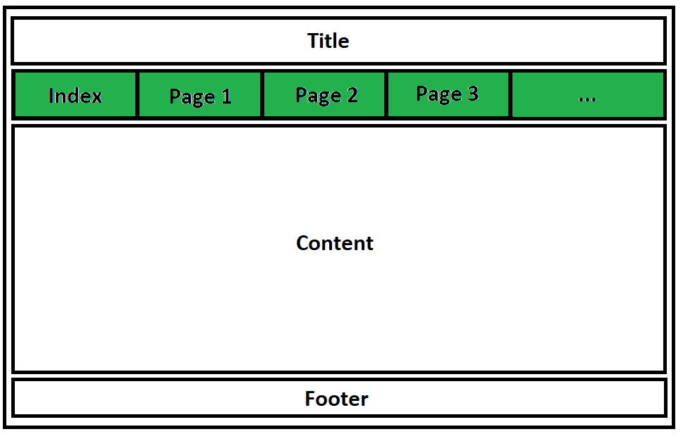

Instructions:

1. First, make sure you have **finished the upgrade** of **your website** by moving all **CSS** declarations to the **external stylesheet** as it was required in previous tasks. ***If NOT, do it FIRST!***
2. **Backup** your **former stylesheet** by creating its **copy**. Rename it, e.g. to *oldstylesheet.css*
3. **Edit** your main **stylesheet** in order to create horizontal menu:
   * Use this [example](https://www.w3schools.com/css/tryit.asp?filename=trycss_float5) as a recipe.
   * Apply **display** and **float** properties to move *list items* **side by side**.
   * Resize remaining **div**s to fill the entire width of the page (*just remove any size properties*)

*** *Note: If you have already designed your website with horizontal menu, try to make it vertical instead.*